FOUR PINES COATING, LLC

QUALITY POLICY
At Four Pines Coating, LLC. it is our policy to provide excellence in customer relations and quality services that meet our customers specifications, standards, and contractual requirements. We strive to do so in a timely manner and at a competitive price.
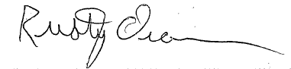
We are committed to continuous improvement and quality service.

Rusty Oram
Owner / Quality Assurance

